**FFR projection based on the factors of FFR and Treasury Yields with HMM**

**Abstract**

As we all know, in the last two years the Federal Reserve has raised interest rates multiple times (increasing the Federal Funds Rate), which has had a significant impact on financial markets around the world. The rate hikes have not only brought about the strength of the US dollar, which affects the Currency Markets, but also the pricing of global assets and the anchoring of sovereigns' credits, which makes the projection of the FFR very important. However, there are a number of obstacles to FFR forecasting: 1) lagging and insufficient publicly available data due to the low frequency of macro data releases; and 2) the susceptibility of market participants to historical data bias (e.g., being overly optimistic about FFR reductions). This study hopes to combine the Taylor Rule, commonly used by the FOMC, with the treasury yields to make a more forward-looking judgement on FFR.

**Introduction**

**Literature Review**

1. Federal Reserve Rate
   1. Monetary Policy

The Federal Reserve, through its monetary policy adjustments, creates a favorable economic environment characterized by appropriate employment rate and stable price [7]. When the aggregate demand lags the economy's capacity to produce, it results in increased unemployment rate and reduced inflation. To counter this, the Federal Open Market Committee (FOMC) intervenes by reducing interest rates and implementing an expansionary monetary policy to stimulate aggregate demand, thereby helping stabilize the economy.

Conversely, if demand for goods and services becomes excessively strong, it can lead to unsustainably employment rate and increased inflation, leading the Federal Reserve employs a contractionary monetary policy by elevating interest rates to guide economic activity back to normal level. The procedure through which the FOMC enacts expansionary and contractionary monetary policies to achieve its goals can be summarized as shown in Fig.1[8].

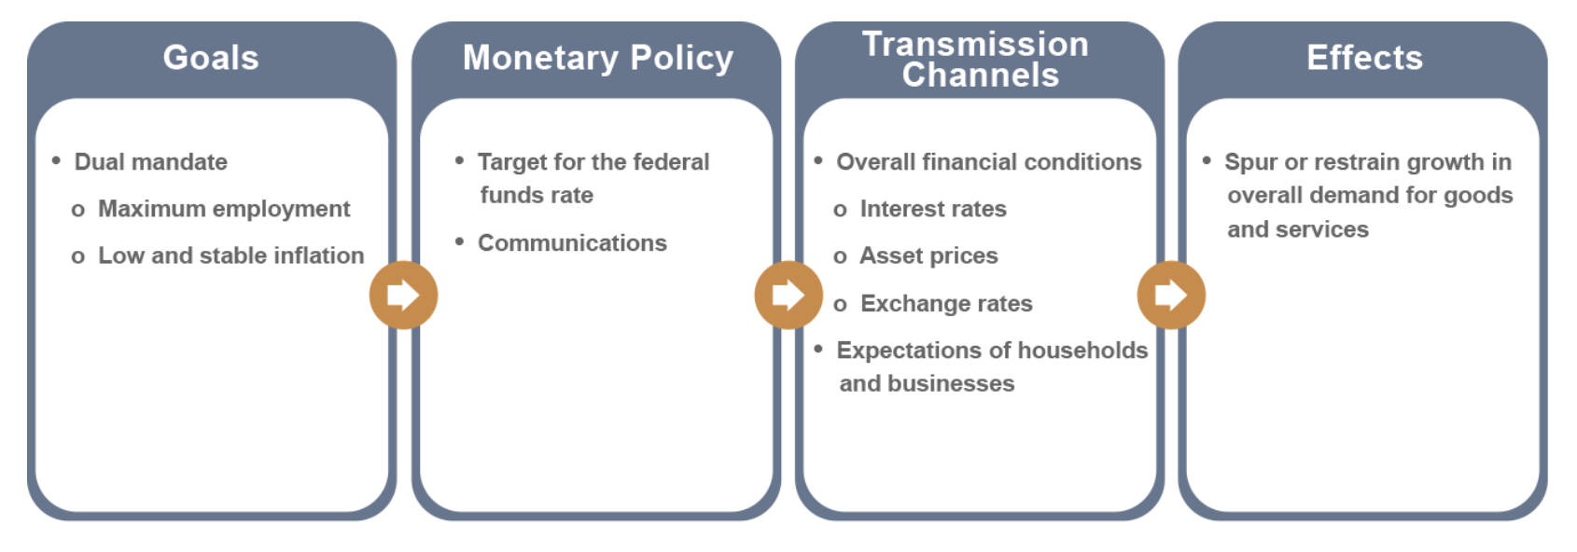

Figure 1. Federal Reserve Monetary Policy

* 1. FFR

The primary method to exert monetary policy is the adjustment of the federal funds rate (FFR) [9]. Banks maintain reserve balances at the Federal Reserve to fulfill unforeseen liquidity requirements, so they engage in borrowing and lending of reserves among one another based on their specific needs. The federal funds rate represents the interest rate at which banks engage in overnight borrowing, which plays a pivotal role in determining the expense of short-term credit.

To impact the federal funds rate, the FOMC can modify the interest rate applied to bank reserves. This adjustment leads to changes in the federal funds rate, aligning it with the FOMC's desired objectives and influencing the cost of short-term interbank credit.

In response to the 2008 economic crisis and subsequent economic recession, Federal Open Market Committee lower the target for the federal funds rate from 5.25% in mid-September 2007 to near zero by the end of December 2008 (See Fig. 2) [10]. This rate reduction was part of the Fed's strategy to stimulate economic activity and provide liquidity to the financial system. The goal was to make borrowing cheaper for banks, businesses, and consumers to encourage spending, investment, and lending. Together with various monetary policies such as buying back government securities, the market responded by purchasing large-scale asset, consequently fostering economic growth, job generation, and a gradual resurgence of inflation toward 2% [8]. Notably, in December 2015, the Federal Open Market Committee initiated the process of increasing the target for the federal funds rate, transitioning from its near-zero level to a more conventional rate. Subsequently, in October 2017, the Federal Open Market Committee embarked on the gradual reduction of its securities holdings, marking another substantial step toward the normalization of monetary policy [11]. As part of this shift, the Committee conveyed that future adjustments in the federal funds rate would serve as the primary mechanism for altering the overall stance of monetary policy.

In the recent context, the U.S. economy has been experiencing a robust recovery after a period of economic disruption, possibly due to the COVID-19 pandemic. Annual inflation rates have risen above the Federal Reserve's target of 2%. Inflation, as measured by the Consumer Price Index (CPI), is at 3.5%, and core inflation (excluding food and energy) is at 2.8%. To address these economic conditions, the Federal Reserve announces an increase in the target FFR from 0.25% to 0.50% [11]. This is the first-rate hike in several years, signaling the central bank's confidence in the strength of the economic recovery.

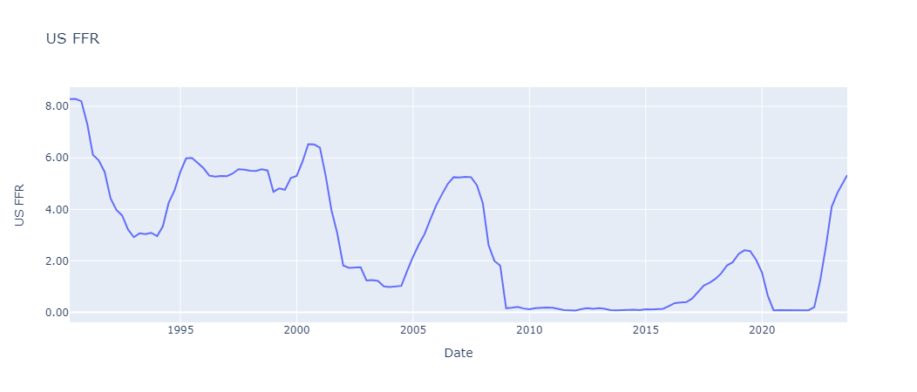

Figure 2. US FFR Diagram

1. Taylor Rule

In a paper published in 1993, John Taylor showed how monetary policy in the United States from 1987 to 1992 was approximated by a formula that related the federal funds rate to three variables. The first variable is the inflation-adjusted long-run federal funds rate, the second is the deviation of current inflation from the 2% target set by the Federal Open Market Committee (FOMC), and the third is the percentage difference between actual GDP and its potential level.

Taylor Rule takes the following general form, with the specific meanings of the indicators shown in the table below [12].

$$R_{t}^{T}=r_{t}^{LR}+π_{t}+0.5\left(π_{t}-π^{*}\right)+0.5(y_{t}-y^{*})$$

|  |  |
| --- | --- |
| Variable | Implication |
| $${FFR}_{t}$$ | Federal fund Rate |
| $${rLR}_{t}$$ | Real Neutral Rate |
| $$π_{t}$$ | Expected Inflation |
| 𝜋∗ | Target Inflation |
| $y_{t}$ − ${yp}_{t}$ | Percent deviation between the current real GDP and the long-term linear trend in GDP |

Table 1. Variables Explanation in Taylor Rule

The Taylor formula illustrates that when inflation surpasses the 2% target, the federal funds rate increases at a rate 1.5 times that of the inflation increase. Furthermore, if the GDP exceeds its potential level, the federal funds rate increases by 0.5 times the difference between the GDP and its potential level.

The Taylor rule embodies the fundamental principles of monetary policy discussed earlier. Firstly, when the real long-term neutral federal funds rate, the actual and target inflation rates, and the real GDP level and its potential are all known, the adjustment based on the difference between the GDP and its potential level is zero, making FFR prediction feasible. Secondly, it advocates for higher FFR in response to rising inflation or increased resource utilization, and lower FFR when inflation subsides or resource utilization declines. This alignment corresponds with the Federal Reserve's dual mandate. Lastly, the equation dictates that the federal funds rate should be adjusted by more than a one-to-one ratio when inflation experiences upward or downward movements, a characteristic often referred to as the Taylor principle.

Federal Reserve officials and economists later introduced several alterations to the variables used in the Taylor Rule, aiming to provide a more accurate representation and interpretation of shifts in the real-world scenario and policy structure. As a result, numerous revised iterations emerged (Table. 2) [13].

|  |  |  |  |
| --- | --- | --- | --- |
| Rules | Formula | Coefficient of Output gap | Coefficient of Inflation gap |
| Bernanke Rule |  | 1 | 0.5 |
| Evans Rule |  | 2 | 0.5 |
| Yellen Rule |  | 0.5 | 2 |
| Bullard Rule |  | 0.1 | 1.5 |

Table 2. Adjusted versions of Taylor Rule

1. Treasury Yield

U.S. Treasury yield is the yield on U.S. government bonds, whose metric measures the return an investor can earn by purchasing U.S. government bonds. U.S. government bonds are bonds issued by the government to raise funds and are usually classified as having different maturities, including short-term, intermediate-term, and long-term bonds.

Treasury yield is often used by investors and economic observers as an indicator of risk and market expectations. Based on the risk-neutral interpretation, treasury yields are equal to the average value of expected future short rates [5]. A low Treasury yield may indicate market concerns about future economic uncertainty, while a high Treasury yield may reflect investor optimism about economic growth and inflation. In addition, Treasury yield is used to determine the pricing of other financial instruments, such as mortgage rates and corporate bonds. Treasury yields can reflect economic conditions, monetary and fiscal policies, and expectations about future economic activity, real interest rates, and inflation [6]. What can be agreed upon is that whenever macroeconomic data is released differently than the consensus, treasury yields always have a noticeable jump, indicating the influence of macro economy situations to the treasury yields. In this research, we take 6 U.S. treasury yields from Bloomberg into consideration according to the dataset coverage [1], and the remained NAN values are forward filled based on the previous dates’ yield data. A visualization of the Treasury Yields is shown in Fig. 3:

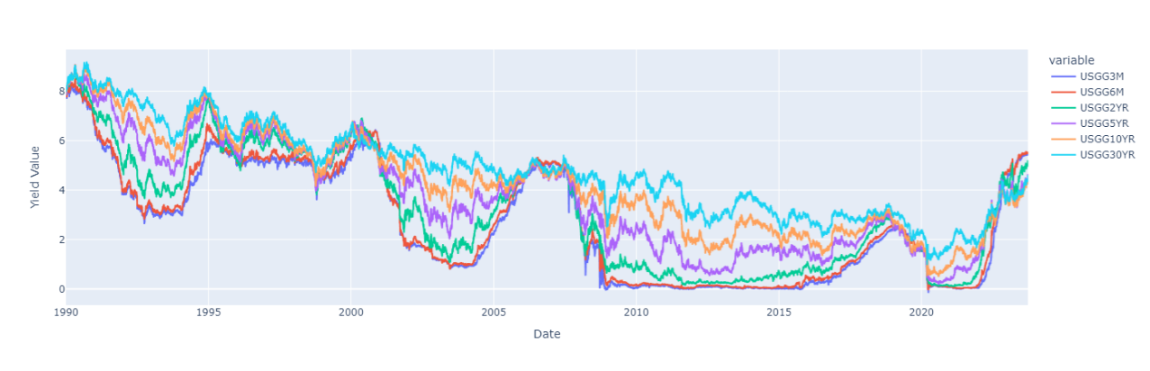

Figure 3. US Treasury Yields Diagram (Maturities including 3, 6 Months, 2, 5, 10, and 30 Year)

Additionally, the term structure of the treasury yields is also an important dimension to understand the economic situation at that point of time. First, regarding the shape of the yield curve at a given point in time, broadly speaking the curve should show an upward sloping trend, but the rate of increase in interest rates decays as maturity increases. This shape is supported by the principles of Expectation, Bond Risk Premiums, and Convexity Bias as stated by Ilmanen. [14] In the history, researchers were interested in proposing models to fit the treasury yield curve better or analyzing the components from the yield curve, and there are indeed the components named level, slope, and curvature that is economically explainable to the structure of yield curve [15]. By reviewing the yield curve in Fig. 3, we can visualize that the up and down shifts in the interest rate curve are essentially joint (as measured by level), and that in most cases the curve with high maturity lies on top (can be illustrated by slope). Various experimented models can prove the existence and significance of these three components, such as the Nelson-Siegel Model [16, 17]. However, this model required some essential tricks to determine the parameters in the model so as to provide a better simulation result. There is another easier method, which is named the Principal Component Analysis that is frequently used in Statistics and Data Science to reduce the dimensionally of the features and get the important ones, that is proved to be useful to model these three factors [18]. From this method, the first three important factors are representing the level, slope, and curvature components in the yield curve, while the remaining are assumed to be noise and filtered out.

Indeed, treasury yields have strong correlation with FFR, especially in the short-term tenor parts, which is because the short-term rate is linked to the FFR to some extent. [8] However, the raise of FFR doesn’t necessarily provide evidence for the change of long-term yield. It can be concluded that this kind of situation could flatten the yield curve as the short side increase more than the long side. We perform a simple correlation measurement to the FFR and the monthly treasury yield rate in Fig. 4, and it is found that the correlation is very close to 1. Whereas, if we lag the treasury yield rate 1 year before and still apply the correlation test, the relationship is still relatively stable. It seems that the treasury yield cannot be directly used as an instrument to project the FFR in the future.

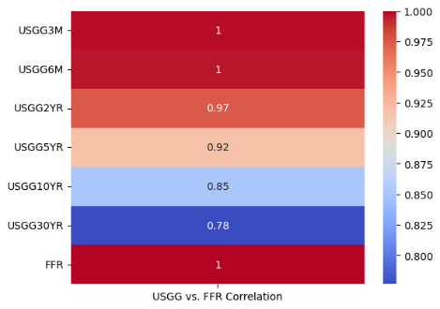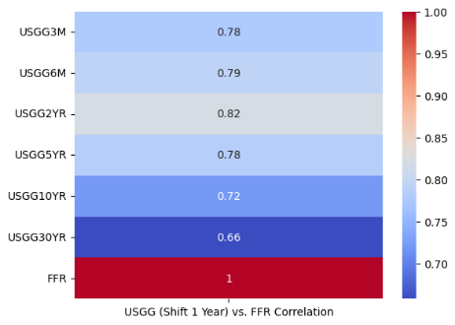

Figure 4. Correlation between the FFR and monthly Treasury yield (left) v.s. Correlation between the FFR and monthly Treasury yield on year before (right)

**Research Objective**

1. Transform the treasury yields data into explanatory features, and then feed them to the GMM-HMM to obtain the leading macroeconomics factors.
2. Construct the model based on the traditional Taylor Rule and the generated new macro factors.
3. Adjust the incorporated information window to test the projection performance of the model.

**Methodologies**

1. Principal Component Analysis
2. GMM-HMM

Macro Factors from Taylor Rule

**??**

According to the basic assumptions of time series modelling, forecasts at moment t cannot use future information, but only current moment as well as ever information [3]. However, in the actual publication of economics data, although different economic indicators reflect economic conditions over the same period of time, they cannot be regarded as variables with the same time stamp due to the difference in publication time. This is also the case in our study, although based on the Taylor Rule, the FFR can be calculated using the relevant macroeconomic indicators for this period, the corresponding macroeconomic indicators are published 1-2 days after the publication time of the FFR (see Fig. ), and therefore in practice it is not possible to use such future information for FFR determination. In reality, researchers generally use the previous period's macroeconomic data as the input factor for the Taylor Rule, however, this can lead to a lagged effect as the calculation of the FFR ignores the most recent period's economic situation. There are also many relevant financial institutions that present alternative data for use, but this is not always publicly available and authoritative.

Perfect Situation:

$R_{T}=\hat{W}M_{T}+\hat{b}+ϵ$, $M_{T}={(π_{T},y_{T})}^{T}$

Real Implication

$\hat{R_{T}}=\hat{W}M_{T-1}+\hat{b}+ϵ$, $M_{T-1}={(π_{T-1},y_{T-1})}^{T}$

$\hat{R_{T}}$ is biased as it doesn’t consider the information from $T-1$ to $T$.

We aim to provide an equation to build the $R_{T}$ with $\hat{R_{T}}$ and the information from $T-1$ to $T$, which is denoted by $m_{T-1}$. As $m_{T-1}$ is the hidden information during the period of ($T-1$,T), it is unobservable, but should still has the linear relationship with $R_{T}$. Therefore, we have the new established formula:

$R_{T}=\hat{W}{[M}_{T-1},m_{T-1}]+\hat{b}+ϵ$, ${[M}_{T-1},m_{T-1}]={\left[{(π}_{T-1},y_{T-1}\right), m_{T-1}]}^{T}$

Based on our thinking, when the FFR is adjusted, Treasury Yield is affected first, while macroeconomic indicators are affected later on. This is because the adjustment of the FFR directly affects the cost of short-term borrowing, so that the short-term borrowing rates of banks and other financial institutions usually quickly follow the change in the FFR, which in turn affects Treasury Yield. However, macroeconomic indicators are affected by a variety of factors, and it usually takes time for changes in the economy to be transmitted, e.g. it takes some time for firms and individuals to make decisions about investing and consuming. time to adjust to the new interest rate environment. In addition, changes in Treasury yields have a direct impact on capital markets, which in turn affect economic activity and ultimately the macroeconomy. [4] stated that the short-term bond yields have relatively significant transmission effects on some output variables, such as consumption, investment, and the consumer price index, which are the macro indicators we concerned.

**Results Analysis**

**Conclusion**

**Reference**

[1] Bloomberg Terminal Data on Treasury Yields (USGG). Bloomberg Terminal, 2023-09-25.

[2] Brooks, Jordan, et al. “Post-FOMC Announcement Drift in U.S. Bond Markets.” *National Bureau of Economic Research*, 1 Oct. 2018, www.nber.org/papers/w25127.

[3] Taylor, Stephen J. *Modelling Financial Time Series*. Hackensack N.J., World Scientific, 2013.

[4] Zhang, Hui, and Hao Huang. “An Empirical Study of the Asset Price Channel of Monetary Policy Transmission in China.” *Emerging Markets Finance and Trade*, vol. 53, no. 6, 8 Nov. 2016, pp. 1278–1288.

[5] Diebold, Francis X, et al. “Modeling Bond Yields in Finance and Macroeconomics.” *American Economic Review*, vol. 95, no. 2, 1 Apr. 2005, pp. 415–420.

[6] Evans, Charles L., and David A. Marshall. “Economic Determinants of the Nominal Treasury Yield Curve.” *Journal of Monetary Economics*, vol. 54, no. 7, Oct. 2007, pp. 1986–2003.

[7]

[8] Seip, Knut Lehre, and Dan Zhang. “The GDP, the US Treasury Yield and the Federal Funds Rate: Who Follows Whom, When and Why?” *Journal of Financial Economic Policy*, vol. ahead-of-print, no. ahead-of-print, 8 June 2021.

U.S. BUREAU OF LABOR STATISTICS. “12-Month Percentage Change, Consumer Price Index, Selected Categories.” *Bls.gov*, 2023, www.bls.gov/charts/consumer-price-index/consumer-price-index-by-category-line-chart.htm.

Stock, James H., and Mark W. Watson. “New Indexes of Coincident and Leading Economic Indicators.” *NBER Macroeconomics Annual*, vol. 4, Jan. 1989, pp. 351–394,